**Roll: 1603108**

**CT Part-2:**

**Code:**

import cv2

import imutils

import copy

image = cv2.imread('D:/Study Materials/Study/Lab/RUET-Lab-Works/4-1/CSE 4106 (Digital Image Processing)/CT/Sample_Image.jpg',0)

cv2.imshow('Original Image', imutils.resize(image, 512))

#Smoothing Filter

#Here the mean filter was manually implemented on the sample image

avg_image = copy.deepcopy(image)

for i in range(1, image.shape[0]-1):

for j in range(1, image.shape[1]-1):

sum_image = sum([image[l, k] for l in range(i-1, i+2) for k in range(j-1, j+2)])

avg_image [i, j] = int(sum_image/9)

cv2.imshow('Average Image (Smoothing Image)', imutils.resize(avg_image , 512))

#Sharpening Filter

#Here the Laplacian Filter was manually implemented on the sample image

lapla_img = copy.deepcopy(image)

for i in range(1, image.shape[0]-1):

for j in range(1, image.shape[1]-1):

tmp = image[i-1, j-1] + image[i-1, j] + image[i-1, j+1] + image[i, j-1] + \

image[i, j+1] + image[i+1, j-1] + image[i+1, j] + image[i+1, j+1] - 8*image[i, j]

lapla_img[i, j] = image[i, j] - tmp

cv2.imshow('Laplacian Image (Sharpening Image)', imutils.resize(lapla_img, 512))

cv2.waitKey(0)

cv2.destroyAllWindows()

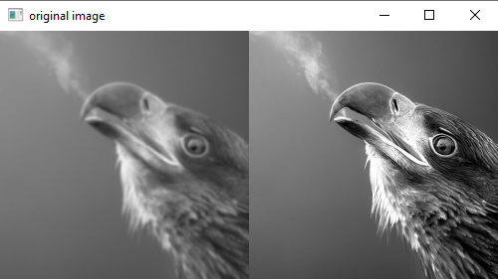**Output:**

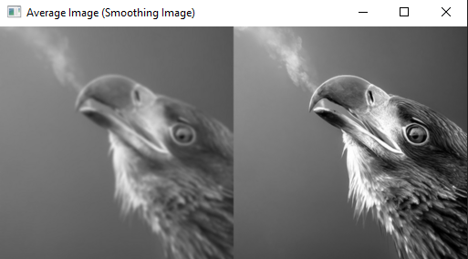**Figure 1:** Original Image

**Figure 2:** Smoothing Image (Mean Filter)

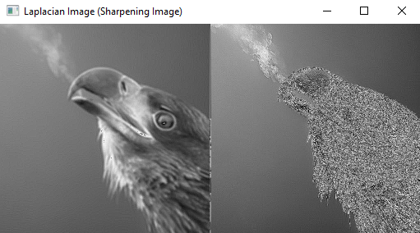

**Figure 3:** Sharpening Image (Laplacian Filter)

**Explanation:**

**Smoothing Filter:**

In this sample Image, firstly the smoothing filter was applied. Here, Mean Filter was used. The Image was firstly shifted to grayscale level or the single channel. Mean filtering works by simply replacing each pixel value in an image with the mean (average) value of its neighbors, including itself. This has the effect of removing pixel values that are out of place in their surroundings. Here, (3 x 3) mask was used here for this filter.

|  |  |  |
| --- | --- | --- |
| $$\frac{1}{9}$$ | $$\frac{1}{9}$$ | $$\frac{1}{9}$$ |
| $$\frac{1}{9}$$ | $$\frac{1}{9}$$ | $$\frac{1}{9}$$ |

Each pixel in the neighborhood has the same weight, and the neighborhood average is used to calculate the filtered output value of the central pixel. This filter suppresses addictive noise. Because an average is calculated for each pixel, the image becomes blurred, especially at the edges. The blurry part gets even blurrier, and the sharpening gets even blurrier.

**Sharpening Filter:**

For the next filter, The Sharpening Filter was used. The Image was firstly shifted to grayscale level or the single channel. Image sharpening is the process of using image differentiation to enhance edges and other mutations, weakening the area where the grayscale transformation is slow and sharpen the area or portion of important pixels of the image. Here, The Laplacian Filter was applied for this filter. A (3 x 3) mask was used as a filter or kernel.

|  |  |  |
| --- | --- | --- |
| 1 | 1 | 1 |
| 1 | -8 | 1 |
| 1 | 1 | 1 |

This Laplacian filter usually find the detail of the image. A Laplacian operator will improve any feature with a sharp discontinuity often like noises. A Laplacian operator can be used to restore fine detail to an image that has been smoothed to remove noise. Here in this image, in the blur part, it sharpens the image but not much but in the sharpen part it finds more details. So, it becomes sharper.